**ASSIGNMENT 1**

**QUESTION 1**

1. **Generate a matrix of scatter plot (SPLOM) of these seven features: PCEPI, CPIAUCSL, ICSA_Week1, ICSA_Week2, ICSA_Week3, ICSA_Week4, and ICSA_Week5. You must properly label the axes and add grid lines to all the scatter plots.**

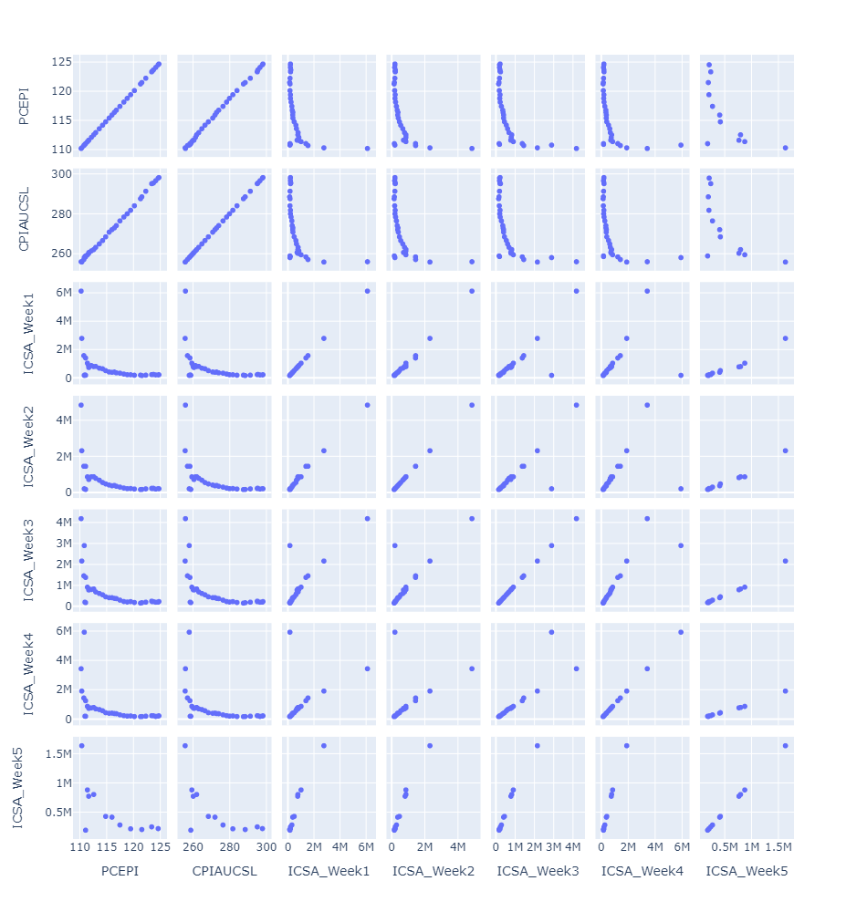

1. **Calculate the Pearson correlations for each pair of the seven features. Display your result up to four decimal places appropriately as a matrix.**

|  |  |  |  |  |  |  |  |
| --- | --- | --- | --- | --- | --- | --- | --- |
|  | **PCEPI** | **CPIAUCSL** | **ICSA_Week1** | **ICSA_Week2** | **ICSA_Week3** | **ICSA_Week4** | **ICSA_Week5** |
| **PCEPI** | 1.0000 | 0.9993 | -0.4692 | -0.5079 | -0.5786 | -0.4934 | -0.6655 |
| **CPIAUCSL** | 0.9993 | 1.0000 | -0.4669 | -0.5056 | -0.5720 | -0.4853 | -0.6669 |
| **ICSA_Week1** | -0.4692 | -0.4669 | 1.0000 | 0.9961 | 0.8436 | 0.4960 | 0.9710 |
| **ICSA_Week2** | -0.5079 | -0.5056 | 0.9961 | 1.0000 | 0.8483 | 0.5003 | 0.9854 |
| **ICSA_Week3** | -0.5786 | -0.5720 | 0.8436 | 0.8483 | 1.0000 | 0.8824 | 0.9907 |
| **ICSA_Week4** | -0.4934 | -0.4853 | 0.4960 | 0.5003 | 0.8824 | 1.0000 | 0.9952 |
| **ICSA_Week5** | -0.6655 | -0.6669 | 0.9710 | 0.9854 | 0.9907 | 0.9952 | 1.0000 |

1. **Calculate the Spearman rank-order correlations for each pair of the seven features. Display your result up to four decimal places appropriately as a matrix.**

|  |  |  |  |  |  |  |  |
| --- | --- | --- | --- | --- | --- | --- | --- |
|  | **PCEPI** | **CPIAUCSL** | **ICSA_Week1** | **ICSA_Week2** | **ICSA_Week3** | **ICSA_Week4** | **ICSA_Week5** |
| **PCEPI** | 1.0000 | 0.9989 | -0.5947 | -0.6143 | -0.7333 | -0.7392 | -0.5524 |
| **CPIAUCSL** | 0.9989 | 1.0000 | -0.6094 | -0.6302 | -0.7474 | -0.7532 | -0.5524 |
| **ICSA_Week1** | -0.5947 | -0.6094 | 1.0000 | 0.9744 | 0.8412 | 0.8340 | 0.9860 |
| **ICSA_Week2** | -0.6143 | -0.6302 | 0.9744 | 1.0000 | 0.8986 | 0.8892 | 0.9842 |
| **ICSA_Week3** | -0.7333 | -0.7474 | 0.8412 | 0.8986 | 1.0000 | 0.9940 | 0.9860 |
| **ICSA_Week4** | -0.7392 | -0.7532 | 0.8340 | 0.8892 | 0.9940 | 1.0000 | 0.9860 |
| **ICSA_Week5** | -0.5524 | -0.5524 | 0.9860 | 0.9842 | 0.9860 | 0.9860 | 1.0000 |

1. **Calculate the Kendall’s Tau-b correlations for each pair of the seven features. Display your result up to four decimal places appropriately as a matrix.**

|  |  |  |  |  |  |  |  |
| --- | --- | --- | --- | --- | --- | --- | --- |
|  | **PCEPI** | **CPIAUCSL** | **ICSA_Week1** | **ICSA_Week2** | **ICSA_Week3** | **ICSA_Week4** | **ICSA_Week5** |
| **PCEPI** | 1.0000 | 0.9899 | -0.5652 | -0.5786 | -0.6650 | -0.6672 | -0.5455 |
| **CPIAUCSL** | 0.9899 | 1.0000 | -0.5685 | -0.5820 | -0.6684 | -0.6706 | -0.5455 |
| **ICSA_Week1** | -0.5652 | -0.5685 | 1.0000 | 0.8998 | 0.8226 | 0.8213 | 0.9394 |
| **ICSA_Week2** | -0.5786 | -0.5820 | 0.8998 | 1.0000 | 0.8544 | 0.8403 | 0.9313 |
| **ICSA_Week3** | -0.6650 | -0.6684 | 0.8226 | 0.8544 | 1.0000 | 0.9539 | 0.9394 |
| **ICSA_Week4** | -0.6672 | -0.6706 | 0.8213 | 0.8403 | 0.9539 | 1.0000 | 0.9394 |
| **ICSA_Week5** | -0.5455 | -0.5455 | 0.9394 | 0.9313 | 0.9394 | 0.9394 | 1.0000 |

1. **Calculate the Distance correlations for each pair of the seven features. Display your result up to four decimal places appropriately as a matrix.**

|  |  |  |  |  |  |  |  |
| --- | --- | --- | --- | --- | --- | --- | --- |
|  | **PCEPI** | **CPIAUCSL** | **ICSA_Week1** | **ICSA_Week2** | **ICSA_Week3** | **ICSA_Week4** | **ICSA_Week5** |
| **PCEPI** | 1.0000 | 0.9993 | 0.6408 | 0.6724 | 0.7126 | 0.6664 | 0.7406 |
| **CPIAUCSL** | 0.9993 | 1.0000 | 0.6398 | 0.6710 | 0.7070 | 0.6611 | 0.7395 |
| **ICSA_Week1** | 0.6408 | 0.6398 | 1.0000 | 0.9940 | 0.8574 | 0.7548 | 0.9706 |
| **ICSA_Week2** | 0.6724 | 0.6710 | 0.9940 | 1.0000 | 0.8620 | 0.7620 | 0.9878 |
| **ICSA_Week3** | 0.7126 | 0.7070 | 0.8574 | 0.8620 | 1.0000 | 0.9646 | 0.9924 |
| **ICSA_Week4** | 0.6664 | 0.6611 | 0.7548 | 0.7620 | 0.9646 | 1.0000 | 0.9964 |
| **ICSA_Week5** | 0.7406 | 0.7395 | 0.9706 | 0.9878 | 0.9924 | 0.9964 | 1.0000 |

**QUESTION 2**

1. **What is the first derivative of the function 𝑓(𝑥)=𝑥2−𝑎 with respect of 𝑥?**
$$f^{'}\left(x\right)=2x$$

2. **You will use the Newton-Raphson method to solve the equation 𝑓(𝑥)=𝑥2−𝑎=0. What is the formula for updating the estimate?**

$$x_{n+1}= x_{n}-\left(\frac{f\left(x_{n}\right)}{f^{'}\left(x_{n}\right)}\right)$$

Example:

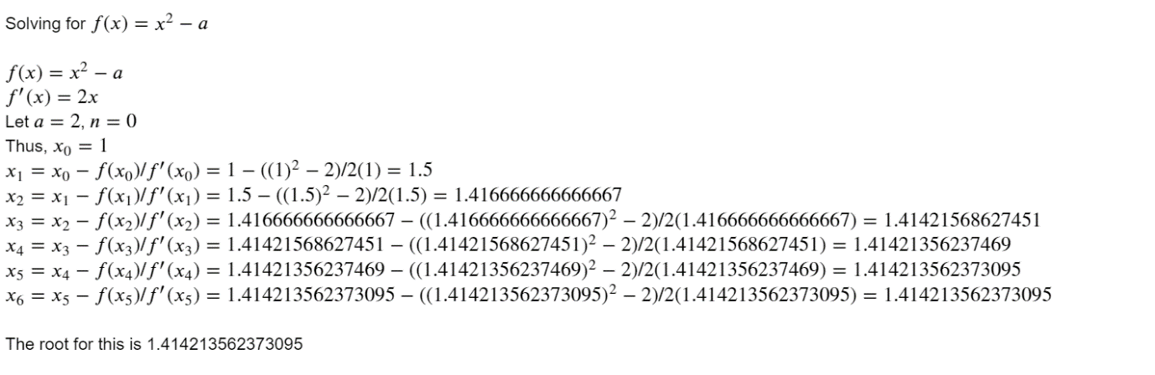

1. **Suppose 𝑎=9 and the initial estimate is 𝑥0=1. The iteration will converge if |𝑥𝑘+1−𝑥𝑘|≤10−13. Please show the iteration history.**

|  |  |  |  |
| --- | --- | --- | --- |
| **Iteration** | **Estimate** | **Function** | **Derivative** |
| 0 | 1 | -8 | 2 |
| 1 | 5 | 16 | 10 |
| 2 | 3.4 | 2.56 | 6.8 |
| 3 | 3.023529 | 0.1417301 | 6.047059 |
| 4 | 3.000092 | 0.0005493332 | 6.000183 |
| 5 | 3 | 0.000000008381903 | 6 |
| 6 | **3** | 0 | 6 |

The root of this equation is: **3.0**

1. **Suppose 𝑎=9000 and the initial estimate is 𝑥0=1. The iteration will converge if |𝑥𝑘+1−𝑥𝑘|≤10−13. Please show the iteration history.**

|  |  |  |  |
| --- | --- | --- | --- |
| **Iteration** | **Estimate** | **Function** | **Derivative** |
| 0 | 1 | -8999 | 2 |
| 1 | 4500.5 | 20245500 | 9001 |
| 2 | 2251.25 | 5059126 | 4502.499778 |
| 3 | 1127.624 | 1262536 | 2255.247668 |
| 4 | 567.8026 | 313399.8 | 1135.605219 |
| 5 | 291.8266 | 76162.76 | 583.653188 |
| 6 | 161.3334 | 17028.47 | 322.666827 |
| 7 | 108.5593 | 2785.112 | 217.11851 |
| 8 | 95.73164 | 164.5476 | 191.463287 |
| 9 | 94.87222 | 0.7386048 | 189.744445 |
| 10 | 94.86833 | 0.00001515256 | 189.73666 |
| 11 | **94.86833** | -0.000000000001818989 | 189.73666 |

The root of this equation is: **94.86832980505137**

1. **Suppose 𝑎=0.0000009 and the initial estimate is 𝑥0=1. The iteration will converge if |𝑥𝑘+1−𝑥𝑘|≤10−13. Please show the iteration history.**

|  |  |  |  |
| --- | --- | --- | --- |
| **Iteration** | **Estimate** | **Function** | **Derivative** |
| 0 | 1 | 0.9999991 | 2 |
| 1 | 0.5 | 0.2499996 | 1.000001 |
| 2 | 0.250001 | 0.06249966 | 0.500002 |
| 3 | 0.125002 | 0.01562469 | 0.250005 |
| 4 | 0.062505 | 0.003905948 | 0.12501 |
| 5 | 0.03126 | 0.000976262 | 0.062519 |
| 6 | 0.015644 | 0.0002438407 | 0.031288 |
| 7 | 0.007851 | 0.000060736 | 0.015702 |
| 8 | 0.003983 | 0.00001496229 | 0.007965 |
| 9 | 0.002104 | 0.000003528338 | 0.004209 |
| 10 | 0.001266 | 0.0000007028126 | 0.002532 |
| 11 | 0.000988 | 0.00000007704356 | 0.001977 |
| 12 | 0.000949 | 0.000000001518794 | 0.001899 |
| 13 | 0.000949 | 0.0000000000006396801 | 0.001897 |
| 14 | **0.000949** | 0.0000000000000000001136083 | 0.001897 |

The root of this equation is: **0.0009486832980505737**